**Faculty of Computer Science & Artificial Intelligence**

**Information System Department**

**CS361 Artificial Intelligence**

**Level (3)**

**An Automated Optical Character Recognition of Handwritten English Letters using Artificial Neural Networks**

**Presented By**

**بولا اشرف رشاد شوقى**

**202000208**

**اسامة سيد مجاهد امين**

**202000107**

**بولس اخنوخ نجيب درياس**

**202000211**

**بيشوى عادل نصيف بدروس**

**202000217**

**كريم سامح حسين محمد**

**202000663**

**شادي خالد عزالعرب حسن ربيع**

**202000422**

**1- Introduction and Overview:**

**- Project idea and overview:**

Optical Character Recognition (OCR) is the mechanical or electronic conversion of scanned images of handwritten, typewritten or printed text into machine-encoded text. It is widely used as a form of data entry. This project proposes an approach to design and implement an OCR system that recognizes English handwritten characters; in this approach Artificial Neural Networks (ANNs) were used as classifiers.

Researchers already paid many efforts in designing hand-written character recognition system because of its important application like bank checking process, reading postal codes and reading different forms. Hand-written digit recognition is still a problem for many languages like Arabic, Farsi, Chinese, English, etc. A machine can perform more tasks than a human being at the same time; this kind of application saves time and money and eliminates the requirement that a human perform such a repetitive task. Here, the goal of a character recognition system is to transform a hand-written text document on paper into a digital format that can be manipulated by word processor software. The system is required to identify a given input character form by mapping it to a single character in a given character set.

**- Applications:**

The applications of the recognition of hand-written English letters are numerous:

**Postal Mail Sorting**

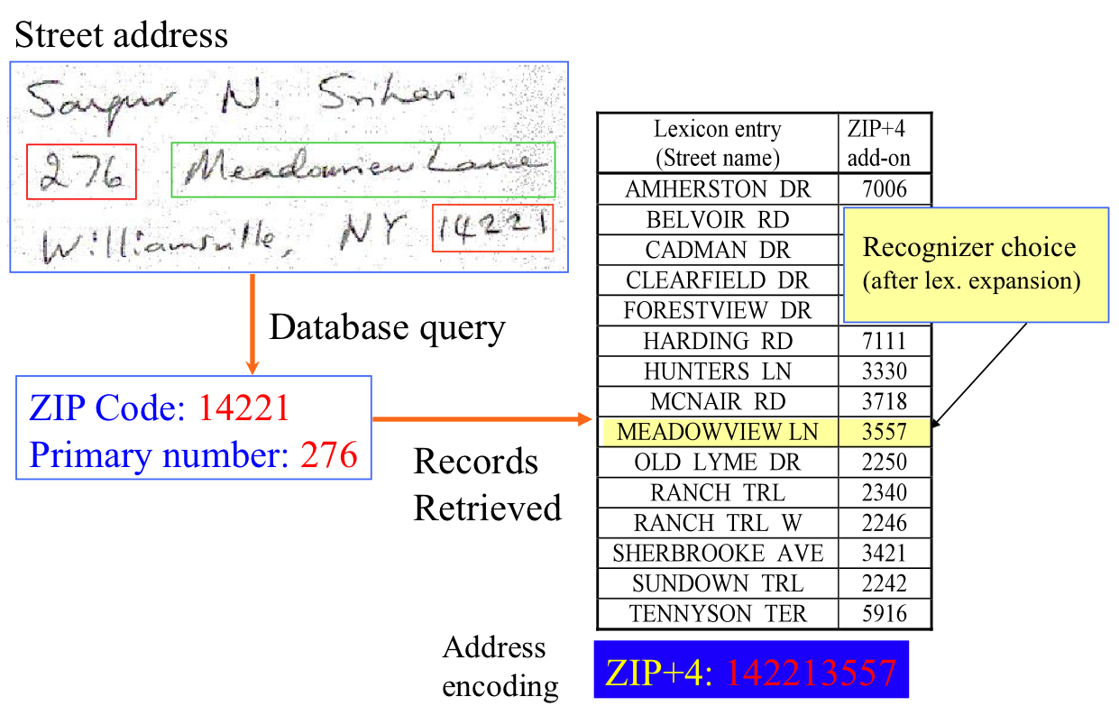

Most of the postal systems in many areas are still manually operated for mail sorting and processing. It has been observed that the manual sorting and processing has many disadvantages such as human errors , more processing time and manpower required. It was intended to propose Automatic Mail Sorting (AMS) system which would eliminate human errors, reduce the mail sorting time and requires minimum manpower. So it was proposed to use a fully automated processing technique involving Optical Character Recognition (OCR) approach. The emergence of OCR has provided a solution for automatic postal address reading. In this technique, a camera is used to capture the images of postal envelops and then the OCR method is applied for the recognition of postal address.

**Bank Check Processing**

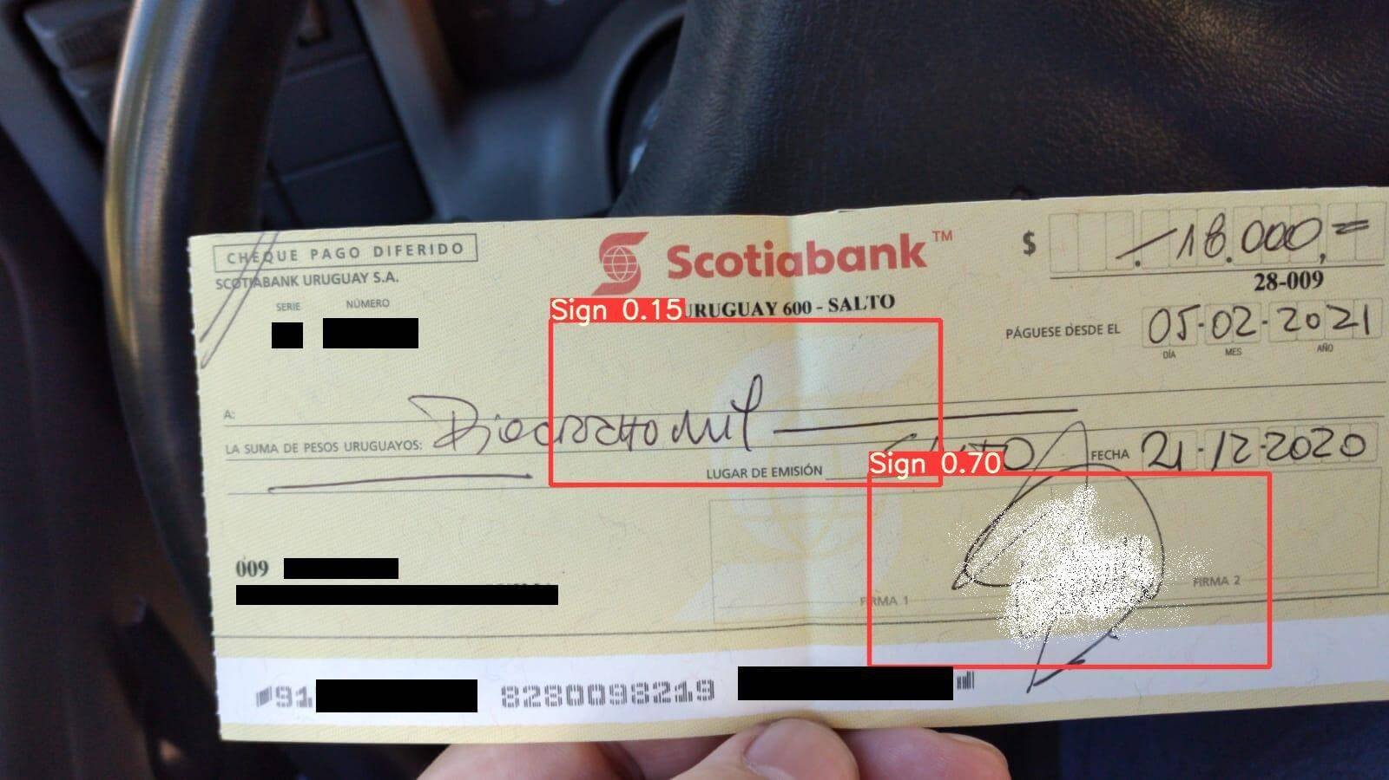

In spite of rapid evolution of digital technologies, a huge number of applications still rely on the use of paper based medium. This is especially true for processing of bank cheques. The pre-printed account number and cheque number might be easily readable and processed automatically. However, the handwritten texts in cheque are usually processed manually involving important time and cost.

An attempt has been made to develop a bank cheque handwritten text recognition system for cheques of by recognizing the handwritten characters present in the ’name’, ’courtesy amount (both in words and ﬁgures)’ and ’date’ ﬁelds by using image processing techniques on handwritten cheque images. Images of bank cheques are fed as input to the proposed system. There are four stages in the proposed system: cropping the image at a speciﬁc location; segmentation of handwritten lines, words and characters; feature extraction from individual characters and digits using Histogram of Oriented Gradients (HOG) method and Grey Level Co-occurrence Matrix (GLCM) texture features; recognition of isolated characters and digits using the Support Vector Machine (SVM) based classiﬁcation process that ensures correct recognition.

**Form Data Entry**

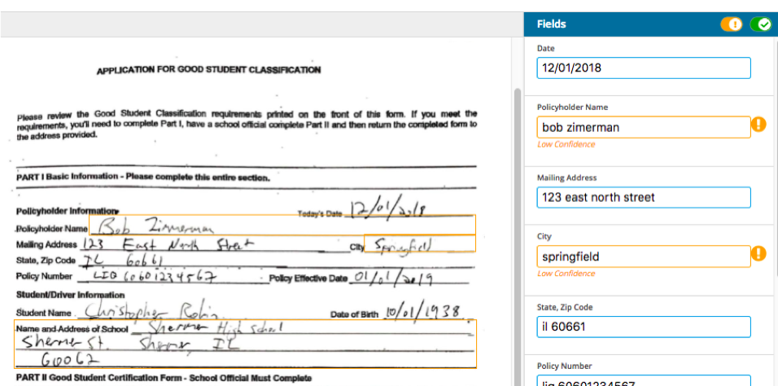

The process of manual data entry used by several industries garners a high error rate. This is because the manual process relies too heavily on a human’s capability to interpret handwritten forms. To reduce the high error rate of data entry, the researchers explored the different processes that comprise optical character recognition (OCR) and used it on a novel digital conversion model for hand-filled forms.

**- Literature Review of Academic publications:**

Optical Character Recognition (OCR) is a system that converts input text into machine-encoded format. Today, OCR is helping not only in digitizing the handwritten medieval manuscripts, but also helps in converting the typewritten documents into digital form. This has made the retrieval of the required information easier as one doesn’t have to go through the piles of documents and ﬁles to search the required information. Organizations are satisfying the needs of digital preservation of historic data, law documents, educational persistence etc. An OCR system depends mainly on the extraction of features and discrimination/classiﬁcation of these features (based on patterns).

Handwritten OCR have received increasing attention as a subﬁeld of OCR. It is further categorized into ofﬂine system, and online system based on input data. The ofﬂine system is a static system in which input data is in the form of scanned images while in online systems nature of input is more dynamic and is based on the movement of pen tip having certain velocity, projection angle, position and locus point. Therefore, an online system is considered more complex and advance, as it resolves the overlapping problem of input data that is present in the ofﬂine system.

One of the earliest OCR systems was developed in the1940s, with the advancement in the technology over the time, the system became more robust to deal with both printed, and handwritten characters and this led to the commercial availability of the OCR machines. In 1965, advance reading machine ‘‘IBM 1287’’ was introduced at the ‘‘world fair’’ in New York. This was the ﬁrst-ever optical reader, which was capable of reading handwritten numbers.

During the1970s, researchers focused on the improvement of response time and performance of the OCR system. The next two decades from 1980 till 2000, the software system of OCR was developed and deployed in educational institutes, census OCR and for recognition of stamped characters on metallic bar. In the early 2000s, binarization techniques were introduced to preserve historical documents in digital form and provide researchers with access to these documents. Some of the challenges of binarization of historical documents were the use of non-standard fonts, printing noise and spacing. In mid of 2000, multiple applications were introduced that were helpful for differently-abled people. These applications helped these people in developing reading and writing skills .In the current decade, researchers have worked on different machine learning approaches which include Support Vector Machine (SVM), Random Forests (RF), k Nearest Neighbor (kNN), Decision Tree (DT), Neural Networks etc.

Researchers combined these machine learning techniques with image processing techniques to increase the accuracy of the optical character recognition system. Recently researchers have focused on developing techniques for the digitization of handwritten documents, primarily based on deep learning approach. This paradigm shift has been sparked due to adaption of cluster computing and GPUs and better performance by deep learning architectures, which includes Recurrent Neural Networks (RNN), Convolutional Neural Network (CNN), Long Short-Term Memory (LSTM)networks etc. This Systematic Literature Review (SLR) serves not only the purpose of presenting literature in the domain of OCR for different languages but also highlight research directions fora new researcher by highlighting weak areas of current OCR systems that need further investigation.

**- Resources:**

- Character recognition using Neural Networks

<https://www.researchgate.net/profile/Ankit-Sharma-13/publication/260230245_Character_Recognition_Using_Neural_Network/links/00463530426811dcd5000000/Character-Recognition-Using-Neural-Network.pdf>

- Optical Character Recognition using 40-point Feature Extraction and Artificial Neural Network

<https://www.researchgate.net/profile/Sayam-Das/publication/337732242_Optical_Character_Recognition_using_40-point_Feature_Extraction_and_Artificial_Neural_Network/links/5de77cc9299bf10bc33d9595/Optical-Character-Recognition-using-40-point-Feature-Extraction-and-Artificial-Neural-Network.pdf>

- Neural Networks for Handwritten English Alphabet Recognition

<https://arxiv.org/abs/1205.3966>

- Neural Network Based Recognition System Integrating Feature Extraction and Classification for English Handwritten

<https://www.ije.ir/article_71978.html>

- Optical Character Recognition on Bank Cheques Using 2D Convolution Neural Network

<https://link.springer.com/chapter/10.1007/978-981-13-1822-1_55>

**2- Proposed Solution & Dataset:**

**- Main functionalities/features:**

Forms containing characters images can be scanned through scanner and then recognition engine of the OCR system interpret the images and turn images of handwritten or printed characters into ASCII data (machine-readable characters). Therefore, OCR allows users to quickly automate data capture from forms, eliminate keystrokes to reduce data entry costs and still maintain the high level of accuracy required in forms processing applications. The technology provides a complete form processing and documents capture solution. Usually, OCR uses a modular architecture that is open, scalable and workflow controlled. It includes forms definition, scanning, image pre-processing, and recognition capabilities.

**- Dataset employed:**

The dataset for this project contains 372450 images of alphabets of 28×2, all present in the form of a CSV file:

<https://www.kaggle.com/datasets/sachinpatel21/az-handwritten-alphabets-in-csv-format>

**- Use-case Diagram:**

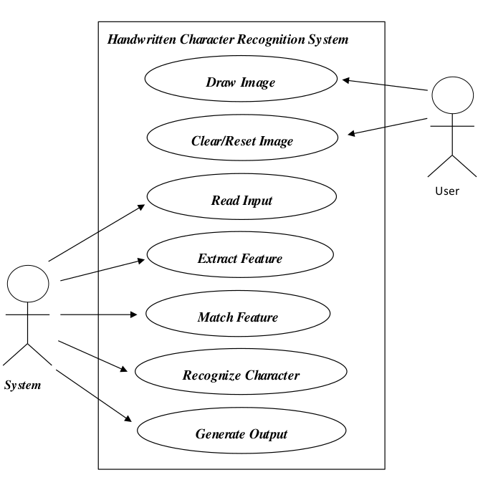

**3- Applied Algorithms:**

**-Artificial Neural Networks algorithm explanation:**

An ANN is based on a collection of connected units or nodes called artificial neurons, which loosely model the neurons in a biological brain. Each connection, like the synapses in a biological brain, can transmit a signal to other neurons. An artificial neuron receives signals then processes them and can signal neurons connected to it. The "signal" at a connection is a real number, and the output of each neuron is computed by some non-linear function of the sum of its inputs. The connections are called edges. Neurons and edges typically have a weight that adjusts as learning proceeds. The weight increases or decreases the strength of the signal at a connection. Neurons may have a threshold such that a signal is sent only if the aggregate signal crosses that threshold.

Typically, neurons are aggregated into layers. Different layers may perform different transformations on their inputs. Signals travel from the first layer (the input layer) to the last layer (the output layer), possibly after traversing the layers multiple times.

**- Advantages & Disadvantages:**

- Advantages:

1. Efficiency

2. Continuous Learning

3. Data retrieval

4. Multitasking is one of the common advantages of Neural Networks

5. Wide Applications

- Disadvantages:

1. Hardware dependent

2. Complex Algorithms are foreseen disadvantages of Neural Networks

3. Black Box Nature

4. Approximate Results

5. Data-dependency

**-Algorithm Flowchart:**

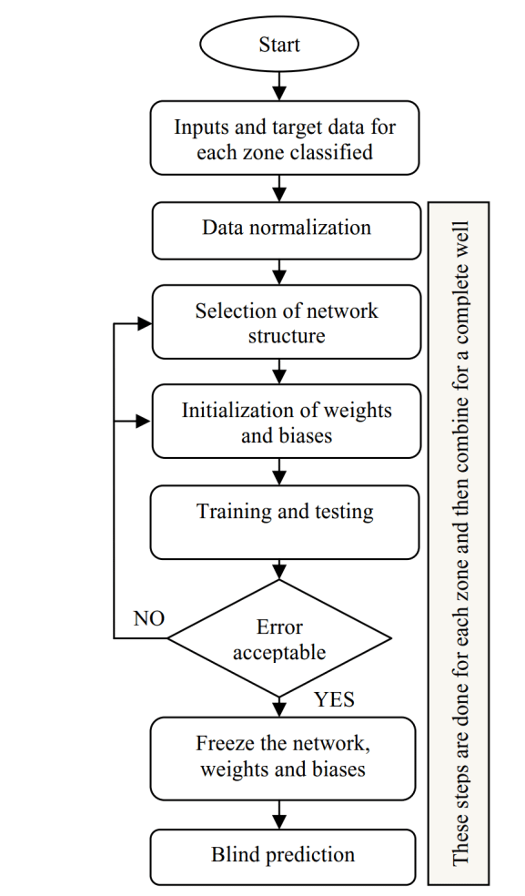

**- Block Diagram of the algorithm:**

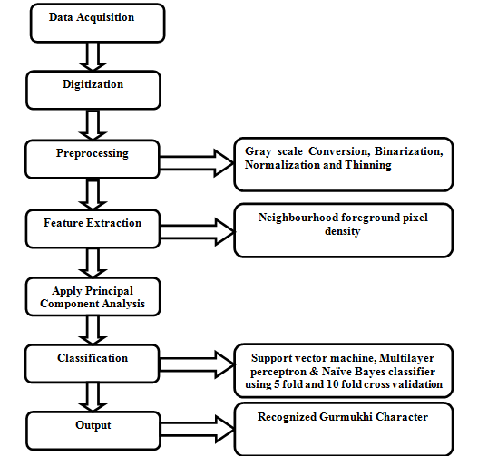

**4- Experiments & Results:**

After applying the algorithm, we got 97% validation accuracy of the model and 8% validation loss.

**Plotting the number of alphabets in the dataset:**

**5- Analysis, Discussion and Future Work:**

**- Analysis of the results:**

By analyzing the OCR we have found some parameters which affect the accuracy of OCR system. The parameters listed in these papers are skewing, slanting, thickening, cursive handwriting, joint characters. If all these parameters are taken care in the preprocessing phase, then overall accuracy of the Neural Network would increase.

**- Advantages & disadvantages:**

- Advantages:

1. Efficiency

2. Wide Applications

3. High Accuracy

4. Low loss of data

- Disadvantages:

1. Hardware dependent

2. Approximate Results

3. Showing results takes time

**- Future Modifications:**

- The future modification for solving the problem can be by applying another machine learning algorithm which has better efficiency and performance for the classification of handwritten characters to recognize them and choose a better approach for extracting a character from an image.

**5- Development Platform:**

**- Tools:**

Jupyter Notebook

**- Programming Language:**

Python

**- Libraries used in the project:**

keras, matplotlib, cv2, numpy, pandas, tqdm, scikit-learn, tensorflow, random

**Shared Folder (GitHub):**

<https://github.com/Karim-Sameh/AI_Project>

**Shortened URL:**

shorturl.at/acpw2